



**Semester One Examination 2018**

**Question/Answer Booklet**

**MATHEMATICS**

**METHODS UNIT 3**

**Section One:**

**Calculator–free**

|  |
| --- |
| Student Name: _____________________________________ |
| Teacher‘s Name: _____________________________________ |
|  |

**Time allowed for this section**

Reading time before commencing work: five minutes

Working time for paper: fifty minutes

**Material required/recommended for this section**

**To be provided by the supervisor**

This Question/Answer booklet

Formula Sheet

**To be provided by the candidate**

Standard items: pens(blue/black preferred), pencils(including coloured), sharpener, correction tape/fluid, erasers, ruler, highlighters

Special Items: nil

**Important note to candidates**

No other items may be taken into the examination room. It is **your** responsibility to ensure that you do not have any unauthorised notes or other items of a non–personal nature in the examination room. If you have any unauthorised material with you, hand it to the supervisor **before** reading any further.

**Structure of this paper**

|  |  |  |  |  |  |
| --- | --- | --- | --- | --- | --- |
|  | Number of questions available | Number of questions to be attempted | Working time (minutes) | Marks available | Percentage of exam |
| **Section One**  **Calculator—free** | **9** | **9** | **50** | **52** | **35** |
| Section Two  Calculator—assumed | 13 | 13 | 100 | 96 | 65 |
|  | | | |  | 100 |

**Instructions to candidates**

1. The rules for the conduct of Western Australian external examinations are detailed in the *Year 12 Information Handbook 2018.* Sitting this examination implies that you agree to abide by these rules.
2. Answer the questions according to the following instructions.

Section One: Write answers in this Question/Answer Booklet. Answer **all** questions.

**Show all your working clearly.** Your working should be in sufficient detail to allow your

answers to be checked readily and for marks to be awarded for reasoning. Incorrect

answers given without supporting reasoning cannot be allocated any marks. For any

question or part question worth more than two marks, valid working or justification is

required to receive full marks. If you repeat an answer to any question, ensure that you

cancel the answer you do not wish to have marked.

It is recommended that you **do not use pencil**, except in diagrams.

1. You must be careful to confine your responses to the specific questions asked and to follow any instructions that are specific to a particular question.
2. Spare pages are included at the end of this booklet. They can be used for planning your responses and/or as additional space if required to continue an answer.

* Planning: If you use the spare pages for planning, indicate this clearly at the top of the

page.

* Continuing an answer: If you need to use the space to continue an answer, indicate in the original answer space where the answer is continued, i.e. give the page number. Fill in the number of the question that you are continuing to answer at the top of the page.

1. The Formula Sheet is **not** handed in with your Question/Answer Booklet.

# Section One: Calculator–free 52 marks

This section has **nine (9)** questions. Attempt **all** questions. Write your answers in the spaces provided.

Spare pages are included at the end of this booklet. They can be used for planning your responses and/or as additional space if required to continue an answer.

* Planning: If you use the spare pages for planning, indicate this clearly at the top of the page.
* Continuing an answer: If you need to use the space to continue an answer, indicate in the original answer space where the answer is continued, i.e. give the page number. Fill in the number of the question(s) that you are continuing to answer at the top of the page.

Working time: 50 minutes

**Question 1 (4 marks)**

A function has 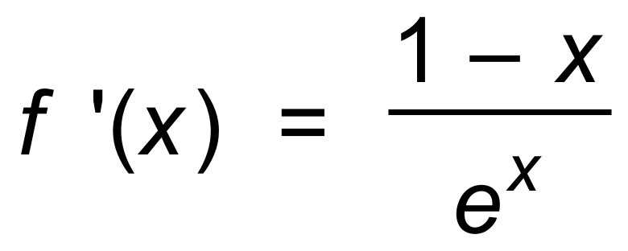 and f (1) = 0.

Determine the x−value of any turning points on the graph of f, and use the second derivative test to determine the nature of those turning points. (4 marks)

**Question 2 (6 marks)**

Consider the following graph and the associated shaded region.

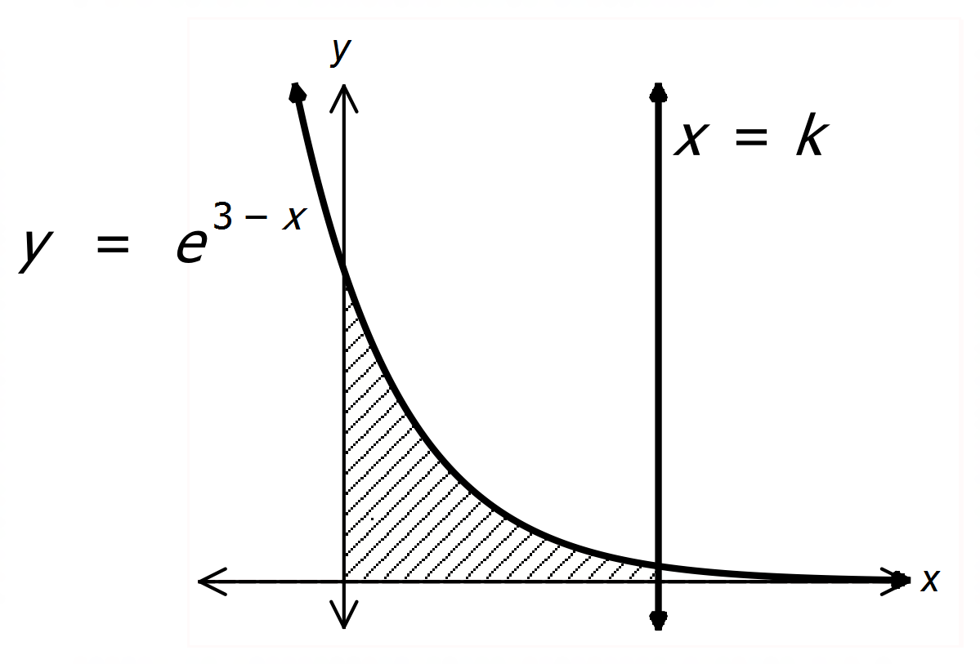

It is known that the shaded area has size either 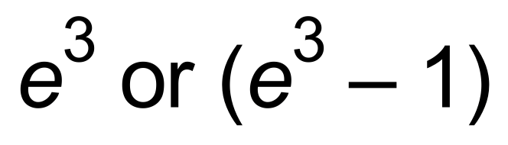.

One of these values is incorrect.

Determine the value of k and state which solution is correct. (6 marks)

**Question 3 (10 marks)**

Consider the graph of 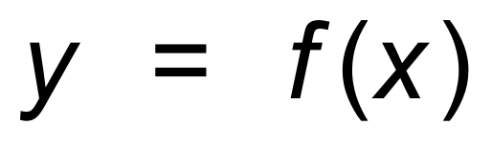 for −1 ≤ x ≤ 4.

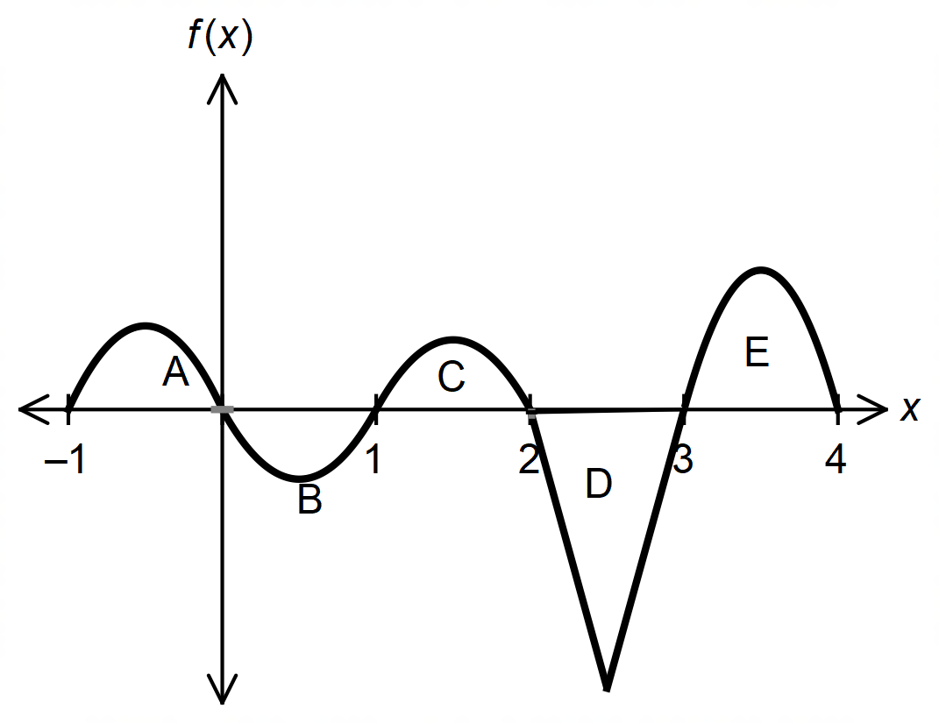

It is known that:

* 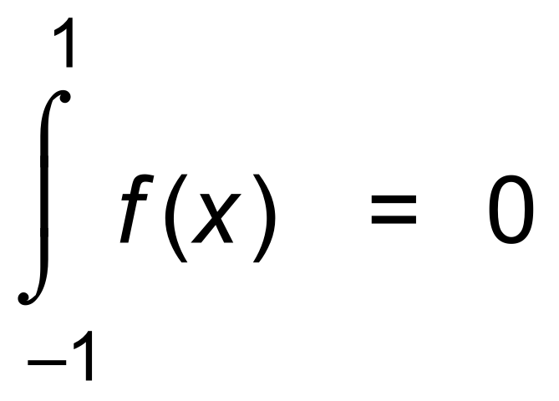
* Areas C, D and E are 1, 5 and 4 units2 respectively.

(a) Determine :

(i) 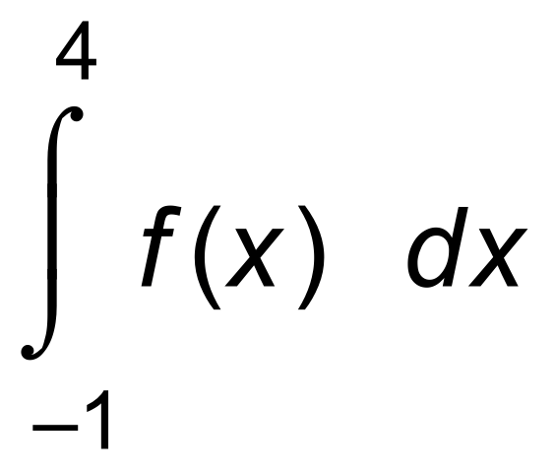 (2 marks)

(ii) 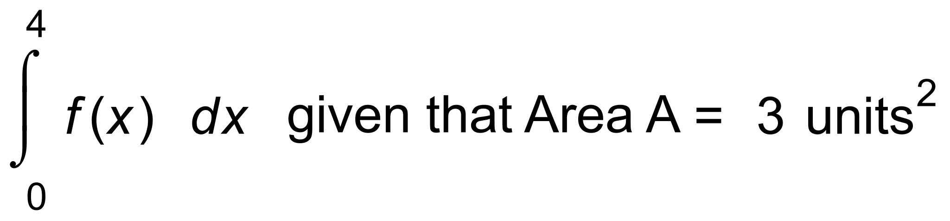 (2 marks)

(iii) the area enclosed by the graph of f and the x−axis between 1 and 4. (2 marks)

(b) Determine the values of:

(i) 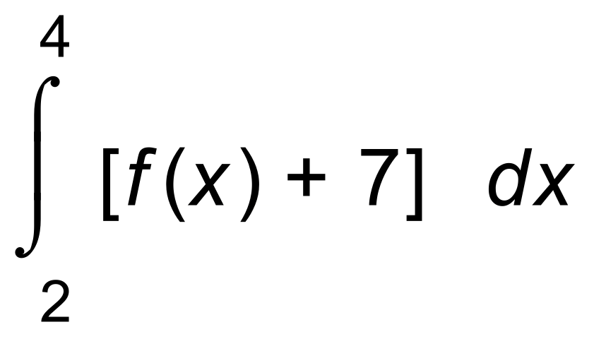 (2 marks)

(ii) 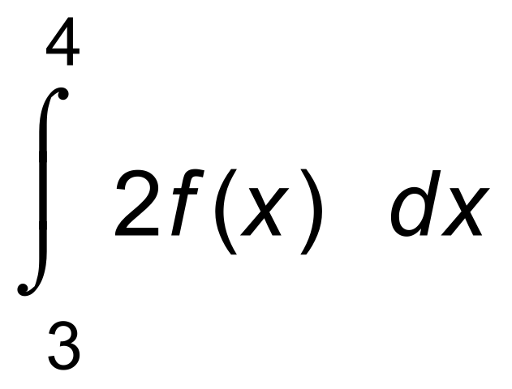 (2 marks)

**Question 4 (6 marks)**

State, with reasons in each case, whether the functions are probability distribution functions for discrete random variables.

(a) 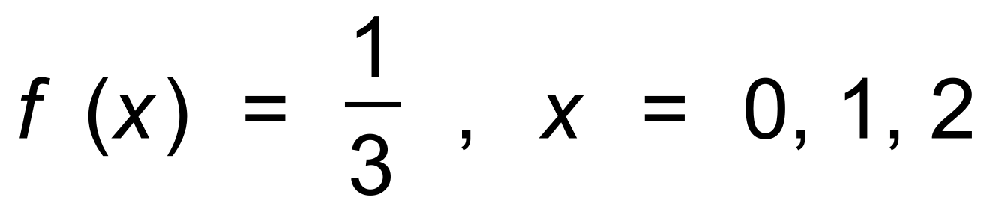 (2 marks)

(b) (2 marks)

|  |  |  |  |  |  |
| --- | --- | --- | --- | --- | --- |
| x | −2 | −1 | 0 | 1 | 2 |
| f (x) | 0.5 | 0.1 | 0.1 | 0.1 | 0.2 |

(c) 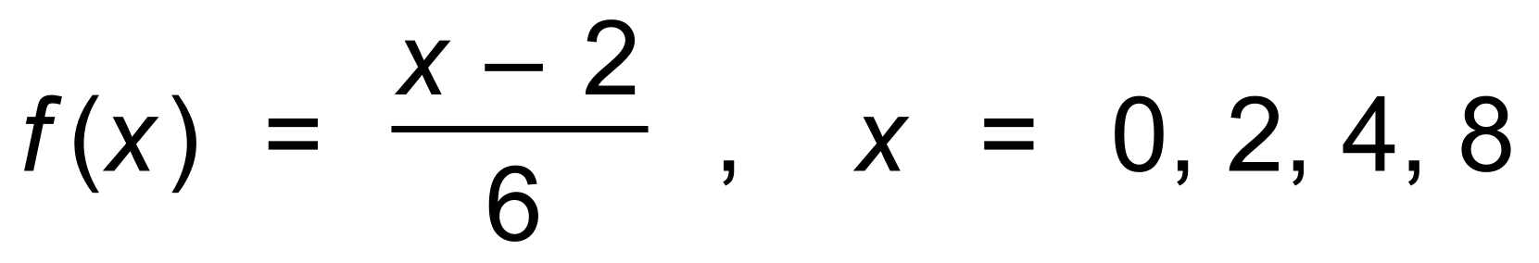 (2 marks)

**Question 5 (8 marks)**

The table below shows the probability function for a discrete random variable, X.

|  |  |  |  |  |  |
| --- | --- | --- | --- | --- | --- |
| x | 0 | 1 | 2 | 3 | 4 |
| P(X = x) | 0.5 | 0.1 | 0.1 | 0.1 | a |

(a) Show why a = 0.2 (1 mark)

(b) Determine P(X < 2 | X ≤ 2). (2 marks)

(c) Calculate E(X), which is the mean of X. (2 marks)

A formula for the variance of X is 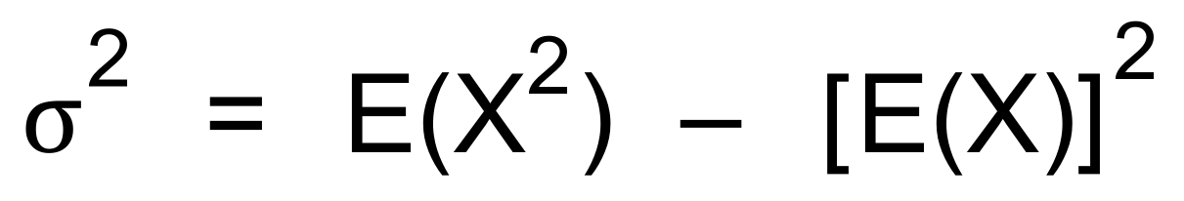, where E is the expected value.

Hence, or otherwise,

(d) determine the variance of X. (3 marks)

**Question 6 (3 marks)**

A discrete random variable X has a mean *m* and variance *v*.

A discrete random variable Y is related to X by the rule Y = 2X + 3.

The mean of Y is 8 and the variance is 20.

Determine the values of *m* and *v*. (3 marks)

**Question 7 (5 marks)**

Determine the following.

(a) 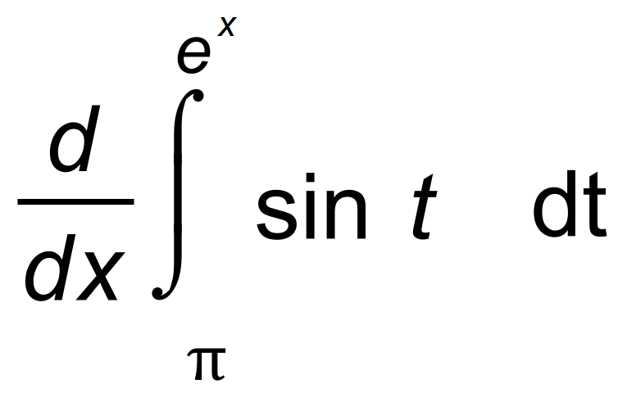 (2 marks)

(b) 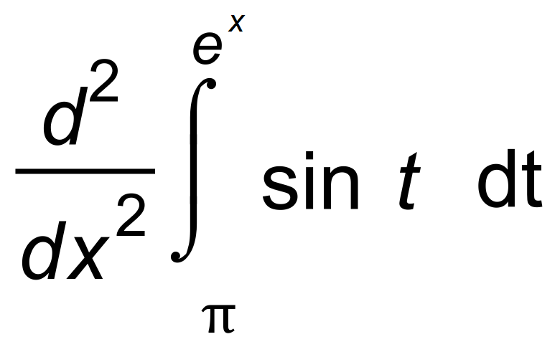 (3 marks)

**Question 8 (5 marks)**

(a) Determine 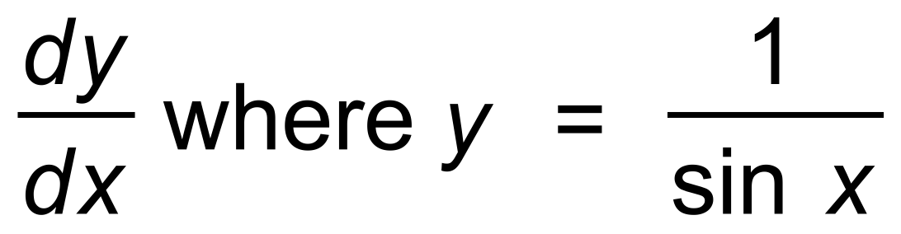 (2 marks)

Hence,

(b) determine 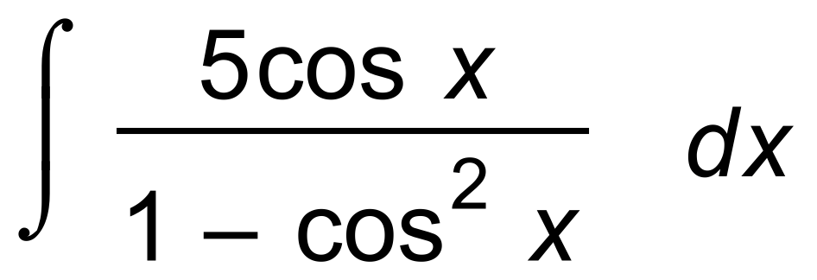 (3 marks)

**Question 9 (5 marks)**

(a) Use the product rule to differentiate 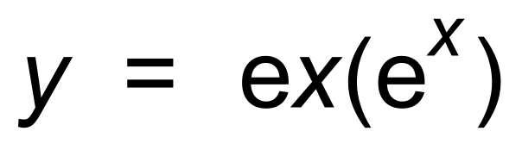.

Give your answer in factored form. (2 marks)

(b) Use the quotient rule and 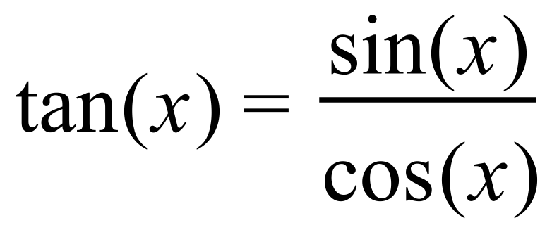 to show that the derivative of 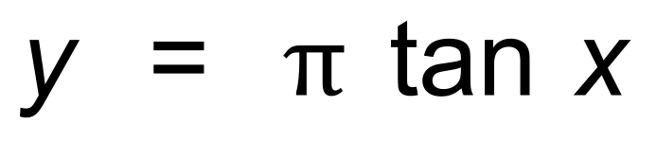

is 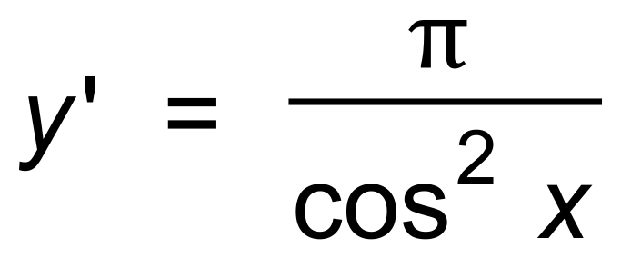 . (3 marks)

**End of Section One**

**Additional working space**

Question number(s): ……………………

WATP acknowledges the permission of the School Curriculum and Assessment Authority in providing instructions to students.